Carole Grace
1943 - 2025

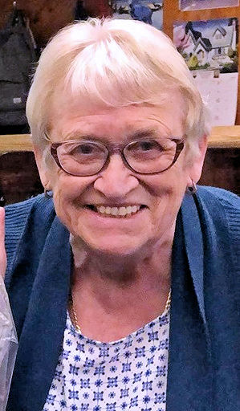 | It is with deep regret that we announce the passing of Carole Grace in January 2025. Carole had been a long time Associate member of ANAVETS Sidney Unit 302 from 2015 through 2024. She would attend many functions including meat draws. Carole was also one of the Mother’s Day team members in the galley cooking and plating for the annual Unit’s Mother’s Day event.

